**Configuring NAT Server to Enable Internet Access to a Company's Official Website**

Student Version



Huawei Technologies Co., Ltd.

|  |
| --- |
| **Copyright © Huawei Technologies Co., Ltd. 2020. All rights reserved.**  No part of this document may be reproduced or transmitted in any form or by any means without prior written consent of Huawei Technologies Co., Ltd.  **Trademarks and Permissions**  HW_POS_RBG_Vertical-150ppi.png and other Huawei trademarks are trademarks of Huawei Technologies Co., Ltd.  All other trademarks and trade names mentioned in this document are the property of their respective holders.  **Notice**  The purchased products, services and features are stipulated by the contract made between Huawei and the customer. All or part of the products, services and features described in this document may not be within the purchase scope or the usage scope. Unless otherwise specified in the contract, all statements, information, and recommendations in this document are provided "AS IS" without warranties, guarantees or representations of any kind, either express or implied.  The information in this document is subject to change without notice. Every effort has been made in the preparation of this document to ensure accuracy of the contents, but all statements, information, and recommendations in this document do not constitute a warranty of any kind, express or implied. |

|  |  |
| --- | --- |
| Huawei Technologies Co., Ltd. | |
| Address: | Huawei Industrial Base  Bantian, Longgang  Shenzhen 518129  People's Republic of China |
| Website: | <https://e.huawei.com/> |

**Huawei Certification System**

Huawei Certification follows the "platform + ecosystem" development strategy, which is a new collaborative architecture of ICT infrastructure based on "Cloud-Pipe-Terminal". Huawei has set up a complete certification system consisting of three categories: ICT infrastructure certification, platform and service certification, and ICT vertical certification. It is the only certification system that covers all ICT technical fields in the industry. Huawei offers three levels of certification: Huawei Certified ICT Associate (HCIA), Huawei Certified ICT Professional (HCIP), and Huawei Certified ICT Expert (HCIE). Huawei Certification covers all ICT fields and adapts to the industry trend of ICT convergence. With its leading talent development system and certification standards, it is committed to fostering new ICT talent in the digital era, and building a sound ICT talent ecosystem.

Huawei Certified ICT Associate-Datacom (HCIA-Datacom) is designed for Huawei's frontline engineers and anyone who want to understand Huawei's datacom products and technologies. The HCIA-Datacom certification covers routing and switching principles, basic WLAN principles, network security basics, network management and O&M basics, SDN and programmability and automation basics.

The Huawei certification system introduces the industry, fosters innovation, and imparts cutting-edge datacom knowledge.

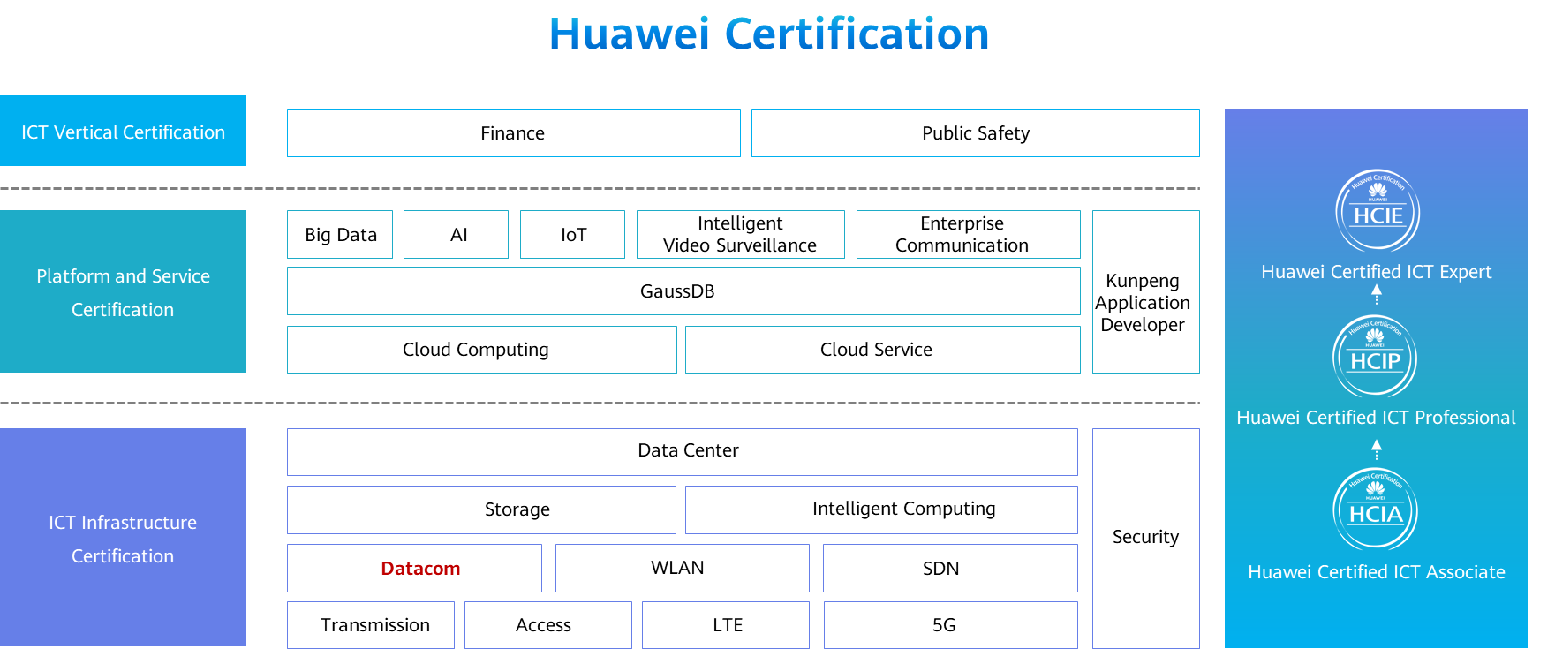

# Configuring NAT Server to Enable Internet Access to a Company's Official Website

## Background

The company Jan16 has deployed a website server and leased only one public IP address to allow external access to its official website. To ensure security of the internal network, NAT Server needs to be configured on the egress router to map the website server's IP address to the public IP address. Figure 1-1 shows the network topology. The specific requirements are as follows:

The internal network segment is 192.168.1.0/24, and the egress network segment is 16.16.16.0/24.

As the company has only one public IP address, NAT Server needs to be configured to translate only port 80 of the website server.

The IP addresses and interfaces of the PC (Internet user) and egress router are shown in the following topology.

## Objectives

Upon completion of this task, you will be able to:

Learn how to configure NAT S erver

Learn how to use the NAT Server function to enable the inside server to be accessed in the external network

## Topology

Lab topology



Since the company has only one public IP address, deploy NAT Server that translates both IP addresses and port numbers to provide services to Internet users. In this exercise, NAT Server needs to be deployed on G0/0/1 of the egress router to translate the website server's private IP address and port 80 into the public IP address (16.16.16.16/24) and port 80 of G0/0/1. In this way, Internet users can access the company's official website. To enable connectivity with the Internet, configure a routing protocol on the egress router according to the ISP network environment.

The IP address planning and interface planning can be referred in the appendix.

## Implementation

### Roadmap

1. Configure interfaces on the egress router.
2. Configure NAT Server.
3. Configure IP addresses for the website server and the PC on the Internet.

### Procedure

Configure IP addresses for interfaces on the egress router.

Configure NAT Server.

On R1, run the **nat server** command on G0/0/1 to define a mapping entry for the internal website server by setting the server communication protocol to TCP, website server's public IP address to 16.16.16.16, server's private IP address to 192.168.1.1, and port number to 80.

[R1]interface GigabitEthernet 0/0/1

[R1-GigabitEthernet0/0/1]

Configure IP addresses for the website server and the PC on the Internet.

Configure the IP addresses of PCs referred by the appendix.

* 1. **Verification**

The details are not provided here.

Verify the NAT Server configuration on R1.

[R1]display nat server

Nat Server Information:

Interface : GigabitEthernet0/0/1

Global IP/Port : 16.16.16.16/80(www)

Inside IP/Port : 192.168.1.1/80(www)

Protocol : 6(tcp)

VPN instance-name : ----

Acl number : ----

Description : ----

Total : 1

The preceding output shows that the configuration already takes effect.

Access the web page of the website server from the PC on the Internet.

Using a Router to function as financial system server，open the WEB management function and the default WEB management port is 80.

#Access the web page of the website server from the PC on the Internet.

[C:\~]$ telnet 10.10.10.1 80

Connecting to 10.10.10.1:80...

Connection established.

To escape to local shell, press 'Ctrl+Alt+]'.

Get

HTTP/1.0 400 Bad Request

Server: AR

Date: tue, 22 dec 2020 07:26:20 GMT

Pragma: no-cache

Cache-Control: no-store

Content-Length: 11

Connection: Close

The PC can successfully access the website server by the **telnet** command,the TCP connection can be established and the HTTP Server send HTTP Response packet.

* 1. **Appendix**

IP address planning

| Device | Interface | IP Address |
| --- | --- | --- |
| R1 | G0/0/0 | 192.168.1.254/24 |
| R1 | G0/0/1 | 16.16.16.16/24 |
| Website server | Eth0/0/1 | 192.168.1.1/24 |
| PC on the Internet | Eth0/0/1 | 16.16.16.10/24 |

Interface planning

| Local Device | Local Interface | Peer Device | Peer Interface |
| --- | --- | --- | --- |
| R1 | G0/0/0 | Switch | G0/0/1 |
| R1 | G0/0/1 | PC on the Internet | N/A |
| Switch | G0/0/1 | R1 | G0/0/0 |
| Switch | Eth0/0/1 | Website server | Eth0/0/1 |